Rocks

Rocks and Minerals
All the rocks in the world are made up of chemicals called minerals. Minerals are solid, inorganic (not living) substances found in and on the earth. Minerals are the building blocks of rocks. Rocks can be a combination of as many as six types of minerals.

Three types of rocks make up the Earth’s crust. Rocks are formed in three different ways to produce igneous, metamorphic, and sedimentary rocks. Igneous rocks form when molten magma cools and solidifies. Metamorphic rocks form when a rock is chemically changed by heat or pressure to form a new rock type. Sedimentary rocks form when fragments of rocks and other debris are cemented together.

Igneous Rocks
The rocks solidify from a mass of molten rock when a lava flow cools and hardens. There are two main types of igneous rock: extrusive and intrusive. Extrusive types form when molten rock comes to the surface and cools quickly, as with lava. This produces a very fine-grained rock. Intrusive rocks are those that solidified underground, cooling slowly to produce coarse-grained rocks. Examples: Granite, basalt, obsidian.

Sedimentary Rocks
Sedimentary rocks are formed when sediment (bits of rock plus materials such as shells and sand) get packed together. They can take millions of years to form. Sedimentary rock is made up of lots of other rocks, or even animal remains(Fossils), all stuck together. Sedimentary rocks are built up of particles laid down as layers or beds of sediment and are later buried , compressed, and cemented into a solid mass. Examples: Sandstone, shale, limestone. Sedimentary rocks often have a layered appearance.
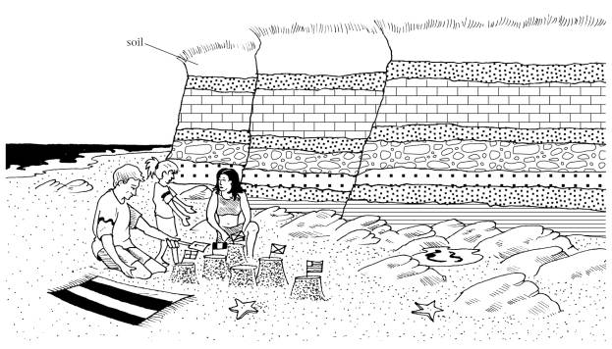
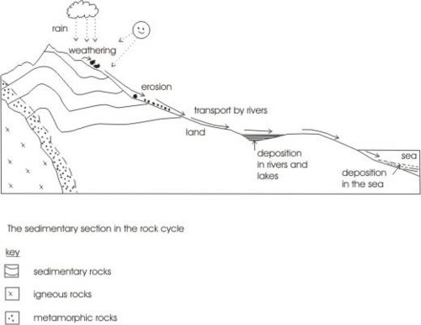

Metamorphic Rocks
Metamorphic rocks are igneous or sedimentary rocks that have been changed by heat, pressure, or both. Metamorphic rocks are usually formed deep within the Earth, during a process such as mountain building. Examples: Schist, slate, marble.

The Rock Cycle

Over many years rock change from one type to another. This is called the rock cycle. Rocks can be changed by the weathering, erosion, heating, cooling and pressure.
Weathering is the breaking down or dissolving of rocks and minerals on Earth’s surface. Water, ice, acids, salt, plants, animals, and changes in temperature are all causes of weathering.
Once the rock has been broken down, a process called erosion transports the bits of rock and minerals away. No rock on Earth’s surface is hard enough to resist weathering. Together, the processes of weathering and erosion carved the Grand Canyon, in the U.S. state of Arizona.

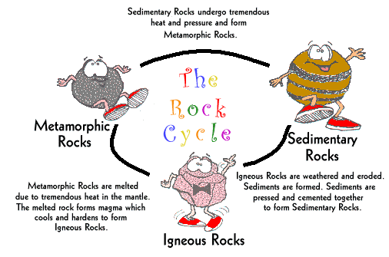

- What is the difference between rocks and minerals?

2. What are the names of the 3 types of rocks?

3. How are igneous rocks formed?

4. What is the difference between to two types of igneous rocks?
Answer
Extrusive igneous rocks cool above the ______________. They cool q_______________. They have _______ crystals.
Intrusive igneous rocks cool below the __________________. They cool s__________________. They have _____________________ crystals.

5. How are sedimentary rocks made?

6. How are metamorphic rocks made?
Key words
Word | Meaning
Sediment
Weathering
Erosion

